Report

Team ID | Individual
Project Title | Smartphone Usage, Digital Addiction & Well-Being Analytics
Maximum Marks | 5 Marks

A report is a comprehensive document that provides a detailed and structured account of data analysis, findings, and insights. It is typically used for in-depth analysis, documentation, and communication of results. Reports are suitable for a diverse audience, including decision-makers, analysts, and stakeholders who need a comprehensive understanding of the data.
Designing a report in Power BI involves connecting to data sources, creating visualizations like charts and graphs, customizing their appearance and interactivity, organizing them logically on the canvas, formatting elements for consistency and clarity, and optionally creating dashboards for a summarized view. Throughout the process, it's essential to consider the audience's needs and ensure the report effectively communicates insights from the data. Finally, iterate based on feedback to continually improve the report's design and usefulness.
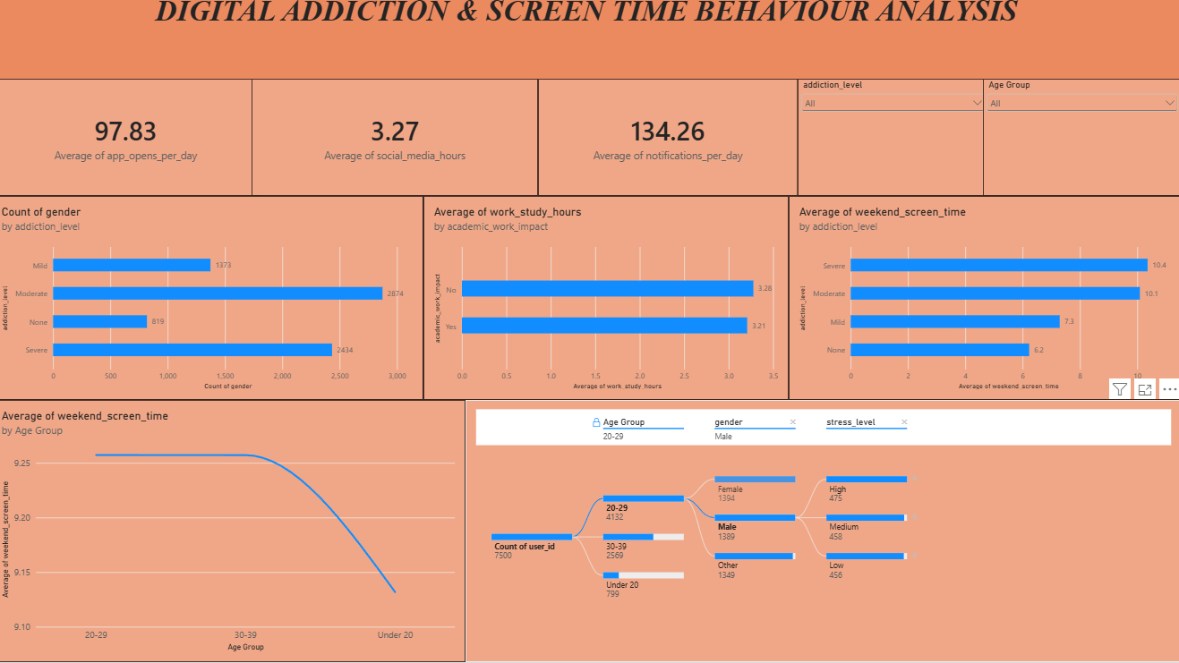
Observations Derived from User Screen Time & Addiction Level Analysis
Observations drawn from reports in Power BI provide valuable insights into behavioral performance, user trends, and psychological impacts.
1. Trends Over Time & Usage Type: Analyze how screen time metrics (e.g., social media hours vs. gaming hours) behave across different usage scenarios to identify lifestyle habits or sudden spikes during weekends.
2. Performance & Demographics Comparisons: Compare performance metrics across different category divisions, such as gender profiles or age groups, to determine which areas demonstrate extreme usage patterns or balanced lifestyles.
3. User & Behavioral Segmentation: Assess multi-layered diagnostic data (such as stress levels, sleep hours, and active notification triggers) to deeply understand user segments and tailor target interventions or wellness strategies.
4. Goal Achievement & Impact Assessment: Measure behavioral outputs against established KPIs (Key Performance Indicators), such as academic work impact or positive addiction thresholds, to evaluate whether digital health objectives are being met.
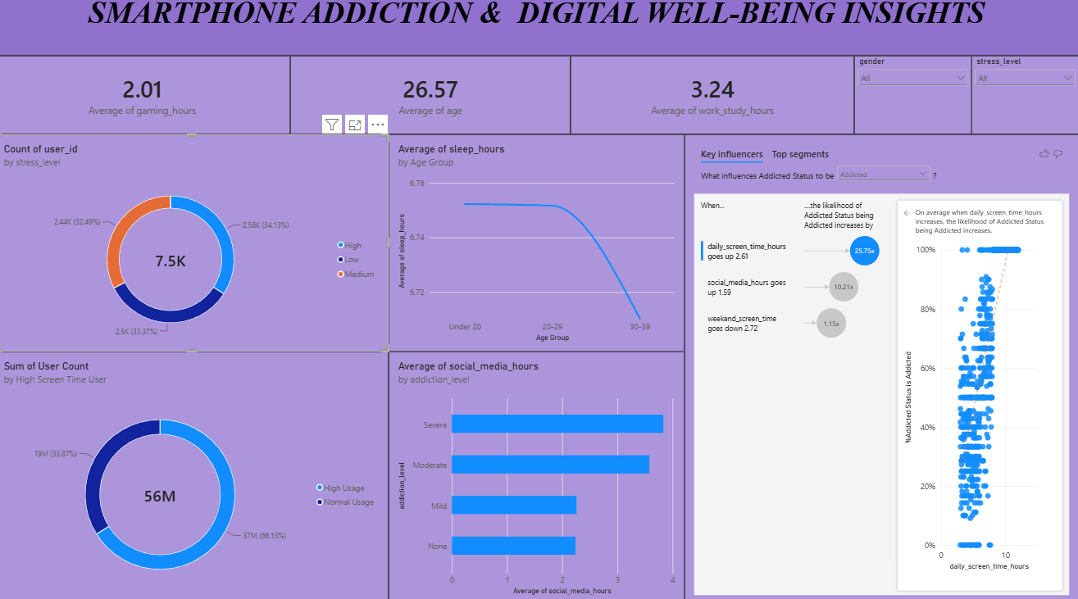

Report Analysis
Gender Distribution vs. Screen Time: The gender distribution metric indicates distinct distribution trends where numerical screen durations and app open metrics differ significantly among Male, Female, and other gender profiles across the dataset.
Age Group Analysis: Among monitored profiles, young adults (ages 18–25) account for a major share of elevated daily screen durations, indicating a significant focus on younger populations. This trend could suggest the need for structural institutional policies aimed at youth digital wellness engagement and focus benefits tailored for this demographic.
Academic & Work Life Impact: A critical subset of users showing intense screen time also directly flagged a positive impact on their academic or work productivity ('Yes' under academic_work_impact). This indicates that high device engagement is heavily split between professional study tasks and leisure addiction.
High Notification Trigger Rate: A total baseline check reveals massive notification volumes (with some individual records exceeding 200 notifications per day), indicating strong system engagement efforts from applications. These metrics should be closely studied by designers for creating successful non-intrusive outreach strategies.

